Migrant Caravan Teach-In Notes
David Fitzgerald
- Why are people leaving Central America?
  - El Salvador and Honduras top 5 highest homicide
    - El Salvador-2nd
    - Honduras-4th
    - Guatemala top 20
  - Extensive gang control, corruption – led to impunity
  - Lowest Human Development Index –
    - El Salvador- 121st, Guatemala- 127th, Honduras- 133rd out of 189.
- Why go to the US?
  - 100+ years of military intervention and economic domination.
  - Immigration patterns from wars in the region during the 1980s where US was highly involved.
- Why travel in a caravan?
  - Migrants are targets of gangs and corrupt police – assault, extort, kill.
    - 193 killed in cartel massacre in 2014
  - Complete impunity – 99% of crimes reported in did not result in a sentence – WOLA.
  - Visibility – less risk and lower detention and deportation problem.
- Increase in asylum seekers in Mexico.
  - From Central America and Venezuela.
  - Economic/political.
  - A third of applicants get protection.
  - Many migrants don’t want to stay in Mexico for different reasons:
    - They see themselves a target.
    - Have family and more opportunities in US
    - Because of a lack of info on high denial rate in US – 75% to 80%.
- What is new about Mexico keeping people bottled up there?
  - Has been happening since 1980s.
  - 1980s–
    - U.S. pays for refugee camps in southern Mexico
    - Mexico imposes travel restriction on Central Americans in northern Mexico
    - Mexico imposes visa requirements on Central Americans
  - 1990s –
    - US finances repatriations of people in transit apprehended in Mexico.
  - 2000s-10s –
    - equip Mexican migration and training under Merida.
  - 2012 –
    - US southern border is now Chiapas. Vertical frontier – extensive transit lines inspection – lots of deportation happens not at the border – but along transit lines.
  - 3.5 million since 1990. More than the US does.
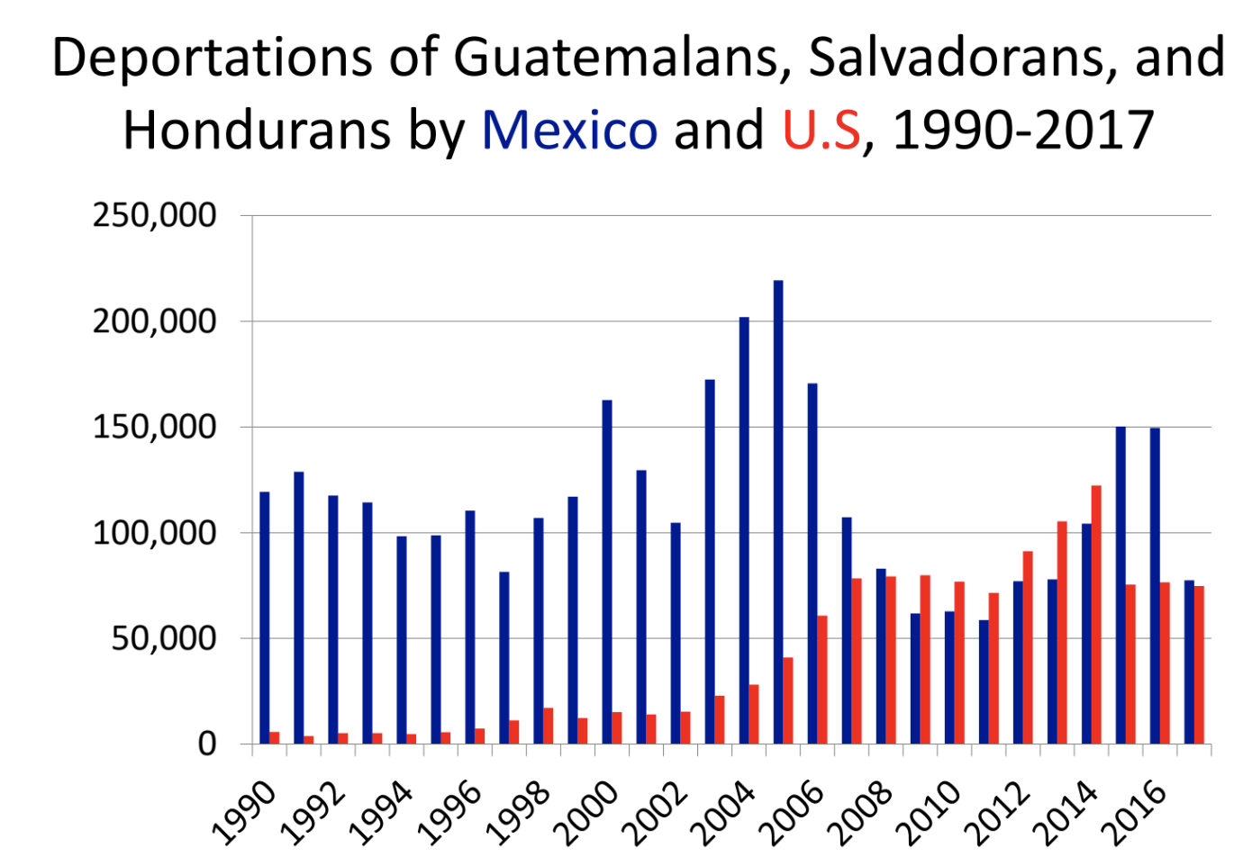

Lynn Stephen
- Why do central American women seek asylum?
  - Accounts from field work: History, politics, networks of people, US foreign policy in Central America, migration because of labor reasons, retreat from violence.
  - The border is woven into family history of people from Guatemala.
  - US support for authoritarian regimes.
- Asylum
  - Accounts from working as a paralegal in the 80s, and processed cases of people seeking asylum.
  - Roll back communism. Now it is keeping out terrorism and keeping out criminals. In the 80s it was denied because state department said conditions in the countries were fine
- Asylum – persecuted in past or fear of persecution due to– membership in a social group – religion – race – nationality or political opinion.
  - 1951 UN convention and 1967 protocol.
  - Asylum cases are seen before a judge in immigration courts.
  - These are refugees, not just migrants.
  - Seeking to escape danger or persecution; Fleeing for their lives.
  - Anyone can apply on US soil. Or a designated point of entry.
- Gender Violence under Asylum
  - Can no longer request asylum on gender grounds (until June of this year.)
  - In June 2018 – Jeff Sessions ruled that domestic violence victims are not a persecuted group. Overruling previous finding. Domestic/gang violence do not qualify. Lynn’s argument is that you cannot separate
  - Case Story of Violence against women act – victims of domestic violence.
    - Upheld in 2014. Elvira – physical abuse as a child, 14 threatened by abuse, pregnant and left by guy, kicked out house with child. Raped on the way home by gang. Threatened to kill her and family if told police. Belief that gangs are protected by police. Depressed, fear, decided to flee. Detained in Arizona. Awaiting asylum hearing with 750,000 others.

Savitry Arvey
- Experience of migrants in the caravan and recognition of positionality.
- How this caravan started and evolved during its journey in Mexico
- Tijuana as a final destination
- Past caravans, and development. Other caravans.
  - Cost is an issue in addition to other things already mentioned
  - Every year since 2015
    - Central American mothers of disappeared migrants – there and back
    - Trans-gay – April 2017 – 16 migrants.
    - Pueblo Sin Fronteras: tradition of the via crusis (since 2010)
      - Trek to draw attention to the issues
      - US intervention, human rights abuses in Mexico
- This caravan is different. Began as uncoordinated effort.
  - Bartolo Fuentes gathered people – 200. Mentioned on TV, people said food and shelter would be provided. Projected on TV and social media. Crossed two international borders. Not one caravan. Lots of disparate groups.
- Timeline of Caravan:
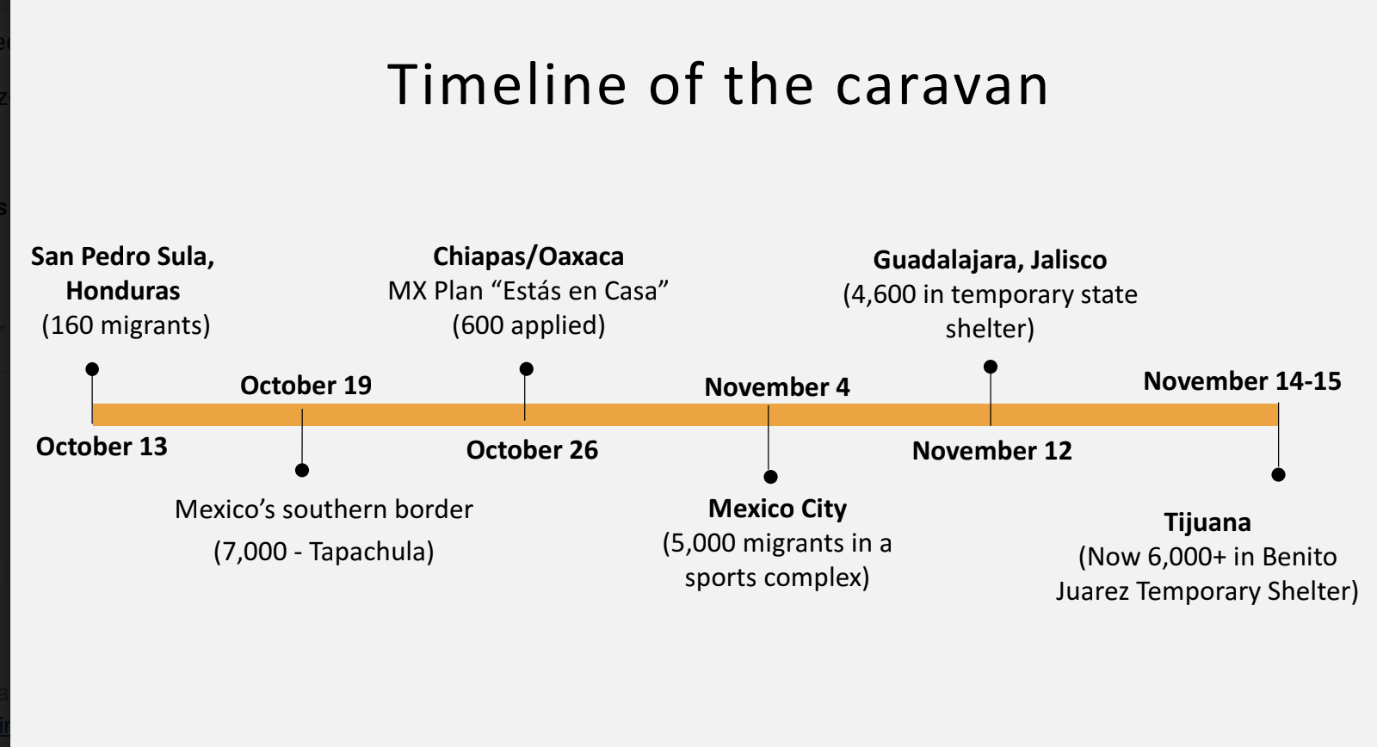
- Blossomed in Tapachula.
- Mexico offered temporary work permits and opportunity to go to school – “estas en casa.”
- 600 applied- not many, since plan would have kept them in Chiapas and Oaxaca. (Poor like home)
- By Nov 4 – 5k migrants in CDMX. Well-received. Mexico City is a sanctuary City.
- 4.5K in Guadalajara.
- From there buses by government and civil society. Nov 14-15 – made it to TJ~6k.
- Why Tijuana?
  - Historical ties to migration flows.
  - Many shelters and NGOs networks
  - Western route up Mexico is safest.
- Migrants saw value of collective action, continued as a group to the border.
- Now, in Tijuana they are faced by a very individualistic process. No longer able to operate together. Baja California government has been slow to react.
  - Tijuana – 6k at shelter. Capacity is 2.5k. A lot of frustration amongst migrants.

Jose Luis Burgos
- UCSD Health Frontiers in Tijuana (HFIT) provides free, quality healthcare for the underserved in Tijuana’s Zona Norte in a respectful environment where students, health professionals, patients, and community members from the border region learn from one another.
- Migrant health crisis in Tijuana.
- HFIT can do rapid HIV viral loads in 2 hours to help people get treatment.
- Has treated 150 this month. Upper respiratory, mental health, skin disorders. TB because of living conditions. Big concern. Fleeing violence. Transphobia.
- Most common complaints are upper respiratory tract infections, mental health issues, skin disorders.
- Concern about TB due to living conditions.
  - Cannot do rapid test of TB. Working on that.
- Current caravan faces barriers to access medical services.
  - March against migrants. Controversial comments from mayor did not help.
  - New barriers to enroll in Seguro Popular. Or get advanced health care.
    - In November, some migrants were denied access to Seguro Popular
- Case stories:
- Jose Paramo – unless you make a formal complaint or a lawsuit to get rights to health, migrants are not getting what they need. Access to denial for patients with HIV. Not just caravan. All impacted. Formal complaints to Mexican Human Rights Commission (CNDH) and Federal courts. Ensure continuity of care.
- FR – people tried to kill her. HIV positive. Not kept confidential. Honduras. Came to Mexico. Viral load not detected. Saw gangs in CDMX. Came to TJ. Again not detectable.
- Luis – slave, making drugs, HIV positive. Need to get into care. Has a viral load. Needs to stay in case.
- Migrant Health Crisis
  - Research is needed to evaluate the impact from U.S. migration policy and migrant receiving communities.
  - Access to health care services for migrants are critical for public health
  - Collaboration across borders is necessary to properly address the current crisis.
  - Longitudinal research on public health and human rights issues around migration is necessary.

Tom Wong
- The administration is filled with evil geniuses that understand how to play the law. “asylum ban” like a Muslim ban. Encouraged people to vote. Voting is a privilege.
- Nov. 9 – after Nov. 6 election, there was a presidential proclamation – to address mass migration. First salvo in asylum ban.
  - If you enter unlawfully then you cannot be granted asylum. (If you come through somewhere other than the port of entry.)
  - Motivated by the idea of threat of mass migration crisis that undermines integrity of the border. Uncontrolled. Crisis.
- Mass migration. Crisis. Claim asylum. But only a handful only get asylum. So we have to clamp down.
- Fact-check.org – Southwest border apprehension from CBP has gone way down. Under 400k.
  - Since like 2008. No crisis. Levels of apprehension are very low historically.
- Claim that not going to get asylum– let’s check facts – Syracuse – getting immigration stats through Freedom of Information Act (FOIA).
  - Credible fear gets checked a second time by an immigration judge. Huge disparity across courts. 1% approval rate in Lumpkin. 50-60% in Arlington, Baltimore, San Antonio, San Francisco.

- Also, on Nov 9. From DHS- Change to how we process asylum claims – interim rules. If president says you cannot claim asylum in between. That will mean we funnel to ports of entry. DHS is on board.

  - But…asylum is a right. It is in the immigration and asylum act. Anywhere. Irrespective of where enter US.
- Temporary Restraining Order and lawsuit on Nov 19, valid until Dec 19.
  - We will change asylum rules in a way that is incompatible with law. Court says president cannot do what he wants to do.
  - President cannot change laws by proclamation. This R.O. gives the president time to figure out how to do what he wants to do in the scope of the law.
- Put asylum ban in broader immigration context – attacks against DACA, etc. Similar MO. They are going to get it done. Litigate, find a way. Go to the supreme court.
  - Supreme Court- not good for progressives.

Rafael Fernandez de Castro Medina

- Saturday, Dec 1 is the inauguration of AMLO. Caravan gives him a good excuse to radically change Mex policy on migration in transit and migration policy in general. Why has government been so weak with current caravan? For the last three administrations- negligent to migrants. Abuses have been there.
  - 15 years ago during a visit to Tapachula, Flor Rigoni said two things – Mexico is a cemetery without crosses. Migrants who have died. Also said, Mexican migrants were 1st class passengers, Central Americans are 2nd class.

- Aug 2010 – San Fernando. Tamaulipas. 72 migrants killed by zetas in hopes of conveying a message to coyotes that if they wanted to cross, had to pay derecho de piso (“right to passage”) Little done to prevent violence from the government.
- Mexico sees NGOs as adversaries, but we have to change that
- Trump put Mexican government between a rock and a hard place. Whatever the government does will look like doing Trump’s dirty work.
  - Plus, transition is happening, which makes it even harder. No one came to meet when Minister from US came to border last week. US says they want people to wait in Mexico during processing case. And Mexico has to deal with this proposal.
- Optimistic message – good opportunity for change. He can do three things:
  - Make refugee camp a model camp in the world – has political clout
  - Come to terms, start to protect rights of migrants in transit, so hard to demand that US protects rights of Mexicans here, migrants in transit are invisible
  - AMLO has been talking about a Marshall plan for central America.
- Opportunity for AMLO to take action regarding the caravan.
  - Mexico voted for him. 53%. People want change.

